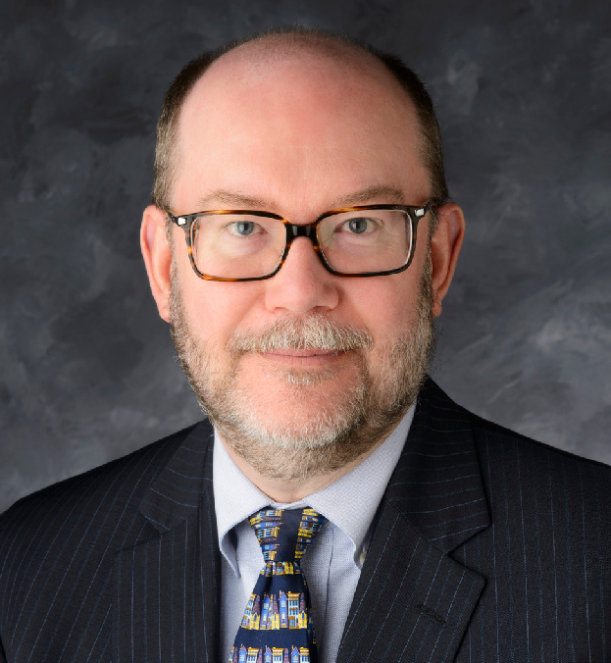
College of Engineering and Computing Porth Distinguished Lecture Series:

Daniel Reed, PhD
Presidential Professor (emeritus)
Scientific Computing and Imaging Institute-University of Utah

Computing Futures in a Changing World:

Insights from a Computing Career

Abstract: The philosopher, George Santayana, famously said, “Those who cannot remember the past are condemned to repeat it.” If there is any enduring lesson in computing, it is the constancy of change, some predictable and some unexpected, that repeatedly disrupts the status quo. Today’s computing ecosystem is in extraordinary flux, with profound implications for research and discovery, economic competitiveness, and national security. From the geopolitics of semiconductor foundries, their exponentially rising costs, and the slowing
of Moore’s Law through the rise of cloud hyperscalers and shifting loci of economic leverage to the profound and uncertain effects of deep learning and AI, the future promises to be qualitatively different from the past. Overlaying these technical and economic issues are equally important questions of policy, law, and ethics. This talk will discuss lessons I have learned over the past fifty years and offer insights for the future.



PRESENTED BY
College of Engineering
and Computing
2:00 P.M. | THURSDAY, APRIL 23
130 WELCOME CENTER | RECEPTION TO FOLLOW

